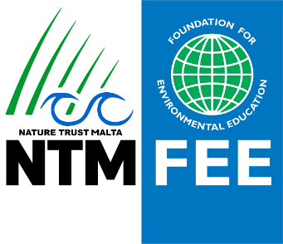
Nature Trust – FEE Malta
Membership Form
Names and Surname

Address

Email

Tel or Mobile

Type of member | Member Eur 0
 | Supporting Member Eur 25
 | Active Member Eur 50
Interests – Please Tick
General
Fauna incl insects
Flora
Habitats
Marine Biodiversity
Other – Please specify
Would you be interested in volunteering? Please select tick
Helping in conservation work in Nature Reserves
Helping in the Tree Nursery (Wied Ghollieqa)
Site Patrolling
Leading Guided walks on our sites
Wildlife Rescue
Wildlife Rehab
Diving and helping in surveys
Clean ups
Fund raising
Marketing
Admin and IT
Other Please specify

All data will be kept confidential and only used to for admin purposes. NTM is complying to GDPR regulations with any data.

